DISD2

XX/09/2022

Reece

I, Raphael Son Hing hereby declare that I did not plagiarize any content in this assignment and that this my own work.  
Signed:_______________

XISD2

Raphael Son Hing ST10117427

Contents

INTRODUCTION 2

PROBLEM DOMAIN 3

SYSTEM REQUIREMENTS 4

1.1 Hardware 4

1.2 Software 5

RISK MANAGEMENT 7

MILESTONES 9

ECONOMIC FEASIBILITY ISSUES 13

GROUP MEMBERS 14

# INTRODUCTION

Greetings, today, we will like to represent our organization called Blue Horizon.

As of recently we have been tasked with Cargo fleet with the construction of a program, one that takes records of various information and data of a transportation network and allows further modification and organization in a manageable manner.

And thus, we our efforts will be to construct a program that befits such a opportunity to manifest our efforts into this application.

# PROBLEM DOMAIN

Firstly we present an excerpt from the instructional documents.

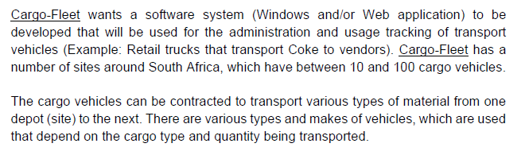

Furthermore, we have divulged further and have summarized other potential issues.

These can be summarized by the following.

* The current system causes several errors on a daily basis.
* To much time daily is consumed correcting for errors allotting to 3 or more hours per on average for office employees.
* Costs are too high and a more efficient method is being researched.

# RISK MANAGEMENT

No project is entirely risk free, at all times there are several factors that could cause upheaval and disoriented the situation to unmanageable levels. However, risks, do not completely come from unexpected circumstances, by researching potential flaws and working our probably scenarios, to an extent certain risks can be mitigated and reduced to with a manageable levels.

Some of the risks that are identified are as follows.

* Financial plans can flux according to exchange rates.
* Locations may experience a margin of error, and depending on location difficulties with the terrain may arise. For example weather difficulties and natural disasters.
* The time frame is strict and only so much time can be allotted without burdening the whole system.

That said, here is an example of how we evaluate the risks involved.

|  |  |  |
| --- | --- | --- |
| Risk | Probability | Management strategy |
| User timesheet | Low | Individual users will have differing amount of effectiveness in the app, which may cause conflicts when comparing data with fellow users. |
| System development | Medium | The data may not be relevant to other outside companies and some records with be irrelevant. |
| Administration | Low | The organization hierarchy may cause conflicts as this endeavor requires input from various sources and the chain of command may suffer confusion. |
| Cost of hardware | Low | Financial problems, purchasing of hardware as well as the expectation of maintenance, and getting the latest version of our current hardware. |
| Errors per day | Medium | We try to reduce common errors and brings the systems as a whole more efficiency. |

# SYSTEM REQUIREMENTS

## Hardware

Various hardware sources are needed for the implantation of this project, there are of course recourses that are more preferable than others as they offer better quality options to implement, however, best case scenarios are hardly feasible and there for a minimum is set.

There are also various factors to take note of such:

•High-traffic or low-traffic

•Number of visitors per day/month

•Maximum number of simultaneous visitors

•Maximum number of lines

•Number of simultaneous orders

•Size and complexity

•Number of articles

•Number of search queries

•Size of the database

Ideally this is our preferred hardware source:

|  |  |  |  |  |
| --- | --- | --- | --- | --- |
| Item | Web server (minimal) | Web server (recommended) | Combined Web & Database Server (minimal) | Combined Web & Database Server (recommended) |
| Processor | 1,6 GHz CPU | 2 x 1,6 GHz CPU | 2 x 1,6 GHz CPU | 4 x 1,6 GHz CPU |
| RAM | 1,75 GB RAM | 3,5 GB RAM | 3,5 GB RAM | 7 GB RAM |
| HDD | 1x 40 GB of free space or more (non-system drive is preferred) 1x 40 GB of free space or more is recommended for the software (system drive) | | | |
| Recommended Microsoft Azure Virtual Machine Configuration | Basic Small VM | Basic Medium VM | Basic Medium VM | Basic Large VM |

As of our current status a suitable system have already been met for minimum values.

However if we are in need of better quality functions in the future, one would purchase them at an online site depending on the prices and budget.

## Software

For the software orientated requirements for the task these are various options that can be utilized:

|  |  |
| --- | --- |
| Component | Notes |
| Internet Information Services (IIS) 6, 7.0, 7.5 or 8 |  |
| Windows PowerShell 2.0, 3.0 or 4.0 |  |
| Microsoft SQL Server 2012 Service Pack 1      -or- Microsoft SQL Server 2012 | * Enterprise, Business Intelligence, Standard, Web, Express |
| Microsoft SQL Management Studio 2012 | * Enterprise, Business Intelligence, Standard, Web, Express |
| Microsoft SQL Server 2008 R2      -or- Microsoft SQL Server 2008 with Service Pack 1 or later      -or- Microsoft SQL Server 2005 with Service Pack 2 or later | * Express, Workgroup, Web, Standard, Enterprise and Datacenter editions are supported * Web edition is recommended * Express edition can only be used if the database size is under 4GB |
| Microsoft SQL Management Studio 2008 R2      -or- Microsoft SQL Management Studio 2008      -or- Microsoft SQL Management Studio 2005 | * Express, Workgroup, Web, Standard, Enterprise and Datacenter editions are supported |

Disregarding basic components like a basic operating system, we require a competent programming software as well as capabilities to access various internet related directories. These are feasibly options for software related matters.

As for procurement of the various software, everything is met, compatible software is already available and the only points on interests of it latest its abilities is upgrading to the lastest versions and its capability to synchronize with newer versions.

(Sana Commerce , 2018)

# MILESTONES

***Milestones and Deliverables***

|  |  |
| --- | --- |
| Team Member Allocation | * Case study reviewed. * Appointment of a team leader and secretary. * Identification of the problem domain * Business processes * System requirements Functions of the system Stakeholders and their functions * Inputs, outputs and processing components. |
| Project Plan Criteria | Project plan criteria are discussed  and reviewed in the team meeting.  Determine the scope of the new  system and the key role players.  • Identification of milestones and  deliverables must be conducted.  • A work breakdown structure; risk  analysis; technical and economic  feasibility must be completed.  • Specify a project schedule using  MS Project as a tool.  • Teams submit a project plan  document. |
| Requirements Analysis Criteria | Requirements analysis criteria are reviewed in the team meeting.  • Determine the functional requirements and develop use case diagrams  • Develop a logical system model indicating inputs, outputs, processes and relationships  • Submit the business solution requirement and analysis document. |
| System Design | Design and solutions criteria are discussed in the team meeting.  • Design the application architecture  of the system using the different  possible models such as three-tier  design; two-tier design; thin or  thick clients; centralised design  with dumb terminals; etc.  Design the GUI; database with full referential integrity; reports and the system’s website. • Solution design document is submitted by teams. |
| Implementation | Implementation criteria are reviewed in the team meeting. • Begin working on implementation with guidance from lecturer.  • Develop the code for the GUI.  • Develop code for input controls.  • Develop code for program modules.  • Develop database tables using a DBMS.  • Populate the database using real or simulated data (at least five records per table).  • Verify and test the system.  • Develop user support i.e. help system and user documentation.  • Working prototype of the business solution is completed |
| Presentation and Demonstration | Presentation criteria are introduced in the team meeting.  • Implement the prototype of your system.  • Present and demonstrate a working prototype system. |

Work Breakdown Structure

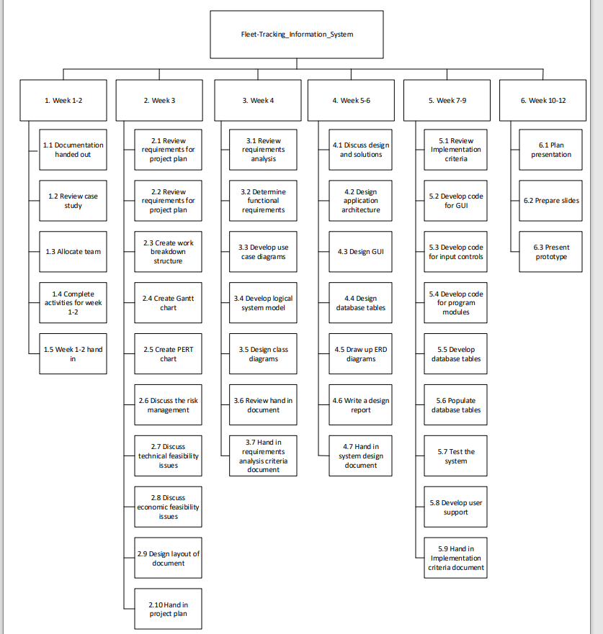

Project Schedule

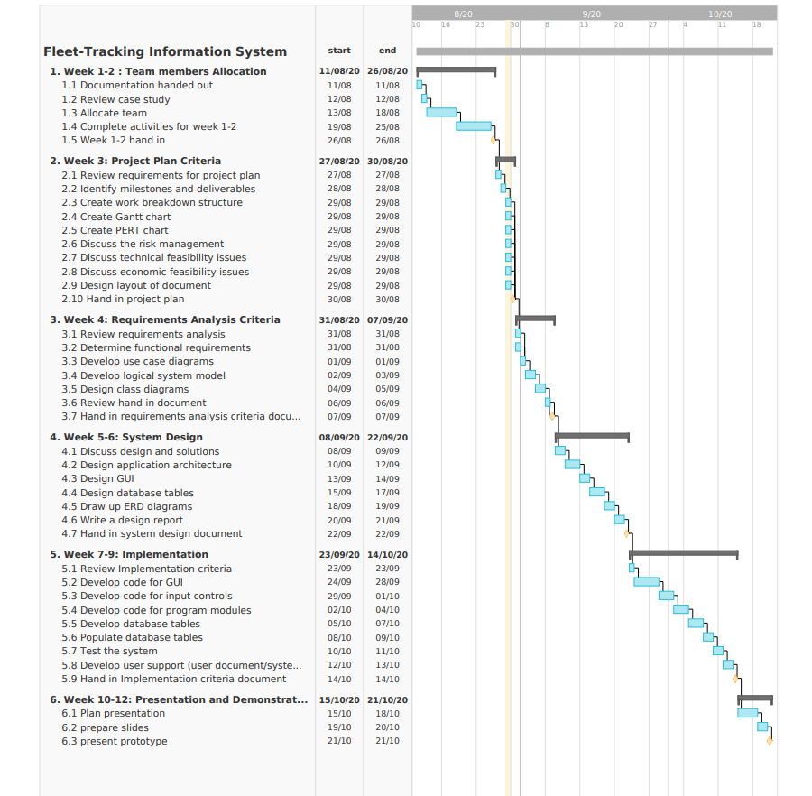Gantt Chart

# ECONOMIC FEASIBILITY ISSUES

|  |  |  |  |  |
| --- | --- | --- | --- | --- |
| Task identification | Team member(s) responsible | Time allocated per task per team member | Tariff per team member in Rand per hour | Cost per Task (time * tariff) |
| Requirements analysis criteria | Raphael Son Hing | 80 | R150 | R12000 |
| Project Plan Criteria | Crosby | 20 | R150 | R3000 |
| System Design | Raphael Son Hing | 200 | R150 | R30000 |
| Implementation | Raphael Son Hing | 250 | R150 | R37000 |
| Presentation and Demonstration | All Group Members | 25 minutes | - | - |
| Total |  | 550h25min |  | R82 000 |

# GROUP MEMBERS

Magcinonke Crosby Maweyi

ST10117465

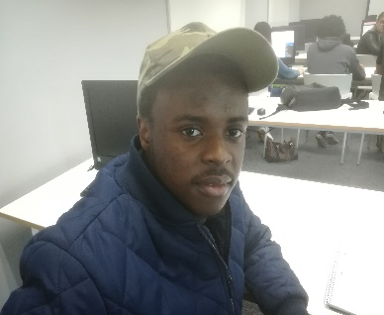

*Resource manger*

Raphael Son Hing

ST10117427

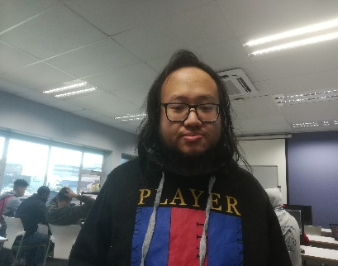

*UI Design*

*Main Programmer*

*Financial Manager*